<!DOCTYPE html>
<html>
<head>
<title>sowmiya</title>
</head>
<body>

<h1> Heading</h1>
<p> paragraph.</p>

</body>
</html>

The <!DOCTYPE html> declaration defines that this document is an HTML5 document

HTML Documents
All HTML documents must start with a document type declaration: <!DOCTYPE html>.

Nested HTML Elements
HTML elements can be nested (this means that elements can contain other elements).
All HTML documents consist of nested HTML elements.
The following example contains four HTML elements (<html>, <body>, <h1> and <p>):

Example Explained
The <html> element is the root element and it defines the whole HTML document.
It has a start tag <html> and an end tag </html>.
Then, inside the <html> element there is a <body> element:

<body>
<h1>My First Heading</h1>
<p>My first paragraph.</p>
</body>
The <body> element defines the document's body.
It has a start tag <body> and an end tag </body>.
Then, inside the <body> element there are two other elements: <h1> and <p>:
<h1>My First Heading</h1>
<p>My first paragraph.</p>
The <h1> element defines a heading.
It has a start tag <h1> and an end tag </h1>:
<h1>My First Heading</h1>
The <p> element defines a paragraph.
It has a start tag <p> and an end tag </p>:
<p>My first paragraph.</p>

The <html> element is the root element of an HTML page
The HTML document itself begins with <html> and ends with </html>.

The <head> element contains meta information about the HTML page

The title Attribute
The title attribute defines some extra information about an element.
The value of the title attribute will be displayed as a tooltip when you mouse over the element:
<head>
<title>sowmiya</title>
</head>
It can also be added to header and paragraph
<h2 title="I'm a header">The title Attribute</h2>

<p title="I'm a tooltip">Mouse over this paragraph, to display the title attribute as a tooltip.</p>
Op:
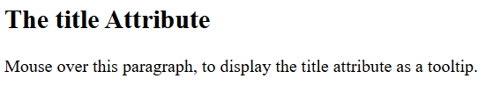
When we hover on The title Attribute it displays as I’m header. When hover on paragraph it displays as I’m a tooltip.
The HTML standard does not require lowercase attribute names.
The title attribute (and all other attributes) can be written with uppercase or lowercase like title or TITLE.
<p title='John "ShotGun" Nelson'>John with double quotes</p>
<p title="John 'ShotGun' Nelson">John with single quotes</p>
Both are correct.
The <title> element specifies a title for the HTML page (which is shown in the browser's title bar or in the page's tab)
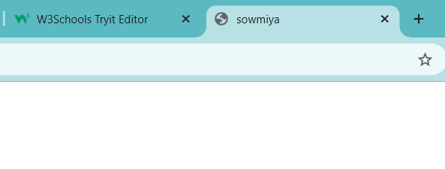

The <body> element defines the document's body, and is a container for all the visible contents, such as headings, paragraphs, images, hyperlinks, tables, lists, etc.
The visible part of the HTML document is between <body> and </body>.

The lang Attribute
You should always include the lang attribute inside the <html> tag, to declare the language of the Web page. This is meant to assist search engines and browsers.
<!DOCTYPE html>
<html lang="en">
<body>
...
</body>
</html>
Or <!DOCTYPE html>
<html lang="en-US">
<body>
...
</body>
</html>
Country codes can also be added to the language code in the lang attribute. So, the first two characters define the language of the HTML page, and the last two characters define the country.

HTML Headings
The <h1> element defines a large heading
HTML headings are defined with the <h1> to <h6> tags.
<h1> defines the most important heading. <h6> defines the least important heading:
For example:
- <h1> - Page title
- <h2> - Section titles
- <h3> - Sub-sections

HTML Paragraphs
A paragraph always starts on a new line, and is usually a block of text. A paragraph always starts on a new line, and browsers automatically add some white space (a margin) before and after a paragraph. You cannot be sure how HTML will be displayed.
Large or small screens, and resized windows will create different results.
With HTML, you cannot change the display by adding extra spaces or extra lines in your HTML code.
The browser will automatically remove any extra spaces and lines when the page is displayed

HTML paragraphs are defined with the <p> tag:

The <p> element defines a paragraph

HTML Horizontal Rules
The <hr> tag defines a thematic break in an HTML page, and is most often displayed as a horizontal rule. The <hr> tag is an empty tag, which means that it has no end tag.
The <hr> element is used to separate content (or define a change) in an HTML page:
<h1>This is heading 1</h1>
<p>This is some text.</p>
<hr>
<h2>This is heading 2</h2>
<p>This is some other text.</p>
<hr>
Op
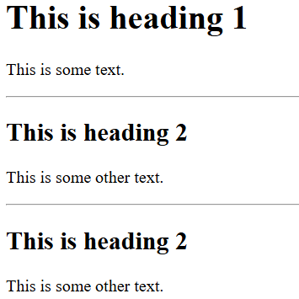

Never Skip the End Tag
Some HTML elements will display correctly, even if you forget the end tag:

Example
<html>
<body>
<p>This is a paragraph
<p>This is a paragraph
</body>
</html>

Empty HTML Elements/ HTML Line Breaks

HTML elements with no content are called empty elements.
The <br> tag defines a line break, and is an empty element without a closing tag:
Use <br> if you want a line break (a new line) without starting a new paragraph:

Example
<p>This is a <br> paragraph with a line break.</p>

The Poem Problem
This poem will display on a single line:

Solution - The HTML <pre> Element

The HTML <pre> element defines preformatted text.
The text inside a <pre> element is displayed in a fixed-width font (usually Courier), and it preserves both spaces and line breaks:

<p>
My Bonnie lies over the ocean.
My Bonnie lies over the sea.
My Bonnie lies over the ocean.
Oh, bring back my Bonnie to me.
</p>
op
<pre>
My Bonnie lies over the ocean.
My Bonnie lies over the sea.
My Bonnie lies over the ocean.
Oh, bring back my Bonnie to me.
</pre>

Op:

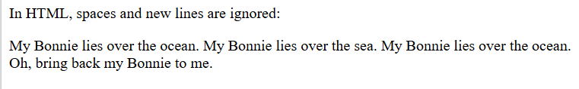

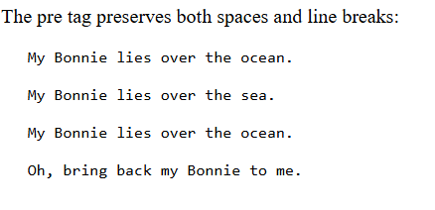

HTML Links
HTML links are defined with the <a> tag:

Example
<a href="https://www.w3schools.com">This is a link</a>
The link's destination is specified in the href attribute.
Attributes are used to provide additional information about HTML elements.

The HTML <a> tag defines a hyperlink. It has the following syntax:
<a href="url">link text</a>
The link text is the part that will be visible to the reader.
Clicking on the link text, will send the reader to the specified URL address.
o/p
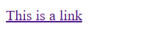
When click on this link the www.google.com will be open
By default, links will appear as follows in all browsers:
- An unvisited link is underlined and blue
- A visited link is underlined and purple
- An active link is underlined and red
Tip: Links can of course be styled with CSS, to get another look!

HTML Links - The target Attribute
By default, the linked page will be displayed in the current browser window. To change this, you must specify another target for the link.
The target attribute specifies where to open the linked document.
- Use the target attribute to define where to open the linked document

The target attribute can have one of the following values:
- _self - Default. Opens the document in the same window/tab as it was clicked
- _blank - Opens the document in a new window or tab
- _parent - Opens the document in the parent frame
- _top - Opens the document in the full body of the window

Absolute URLs vs. Relative URLs
Both examples above are using an absolute URL (a full web address) in the href attribute.
A local link (a link to a page within the same website) is specified with a relative URL (without the "https://www" part):
<h2>Absolute URLs</h2>
<p><a href="https://www.w3.org/">W3C</a></p>
<p><a href="https://www.google.com/">Google</a></p>
<h2>Relative URLs</h2>
<p><a href="html_images.asp">HTML Images</a></p>
<p><a href="/css/default.asp">CSS Tutorial</a></p>

<a href="https://www.w3schools.com/html/default.asp">HTML tutorial</a> is anAbsolute url and <a href="/html/default.asp">HTML tutorial</a> is as relative url.

Link to an Email Address
Use mailto: inside the href attribute to create a link that opens the user's email program (to let them send a new email):
<a href="mailto:someone@example.com">Send email</a>

HTML Links - Use an Image as a Link
To use an image as a link, just put the <img> tag inside the <a> tag:
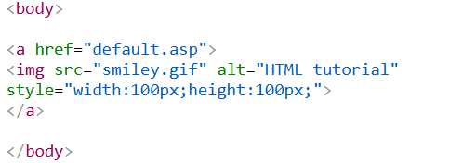
0/p

Width and height off the image is changed in “style” attribute. When click on the image defaulr.asp page has been opened.

Button as a Link
To use an HTML button as a link, you have to add some JavaScript code.
JavaScript allows you to specify what happens at certain events, such as a click of a button:

Example
<button onclick="document.location='default.asp'">HTML Tutorial</button>
Ex

Link Titles
The title attribute specifies extra information about an element. The information is most often shown as a tooltip text when the mouse moves over the element.
<a href="https://www.w3schools.com/html/" title="Go to W3Schools HTML section">Visit our HTML Tutorial</a>
I placed mouse cursor on visit our HTML tutorial it displays as Go to W3Schools HTML section

HTML Images
HTML images are defined with the <img> tag.

The src Attribute
The <img> tag is used to embed an image in an HTML page. The src attribute specifies the path to the image to be displayed:

The source file (src), alternative text (alt), width, and height are provided as attributes:

Example
<img src="w3schools.jpg" alt="W3Schools.com" width="104" height="142">
Alt displays alternate word if the image is not displayed
There are two ways to specify the URL in the src attribute:
1. Absolute URL - Links to an external image that is hosted on another website. Example: src="https://www.w3schools.com/images/img_girl.jpg".
2. Relative URL - Links to an image that is hosted within the website. Here, the URL does not include the domain name. If the URL begins without a slash, it will be relative to the current page. Example: src="img_girl.jpg". If the URL begins with a slash, it will be relative to the domain. Example: src="/images/img_girl.jpg".
Tip: It is almost always best to use relative URLs. They will not break if you change domain.

The width and height Attributes
The <img> tag should also contain the width and height attributes, which specify the width and height of the image (in pixels):

The alt Attribute
The required alt attribute for the <img> tag specifies an alternate text for an image, if the image for some reason cannot be displayed. This can be due to a slow connection, or an error in the src attribute, or if the user uses a screen reader.

The style Attribute
The style attribute is used to add styles to an element, such as color, font, size, and more.
The HTML style attribute has the following syntax:
<tagname style="property:value;">
The property is a CSS property. The value is a CSS value.

Text Color
The CSS color property defines the text color for an HTML element:

Example
<h1 style="color:blue;">This is a heading</h1>
<p style="color:red;">This is a paragraph.</p>

Style- attribute
Color-css
Blue- value
Op:
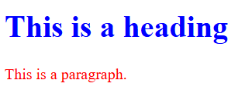

Background Color
The CSS background-color property defines the background color for an HTML element.
<body style="background-color:powderblue;">
<h1>This is a heading</h1>
<p>This is a paragraph.</p>
</body>
If style="background-color:powderblue;" is placed inside body tag, whole page has changed into blue, if style attribute is placed in <h> tag the line with heading has changed into blue. If style attribute is placed in <p> tag the para was changed into blue.
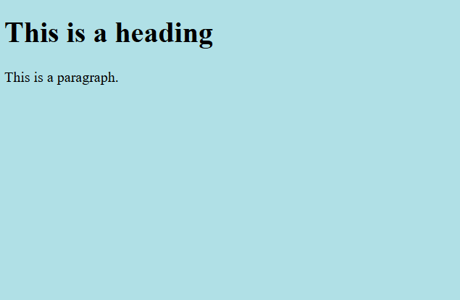
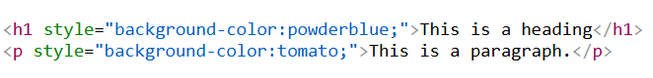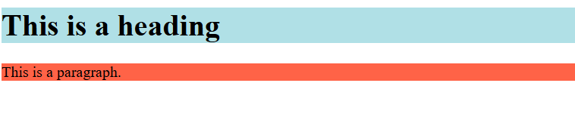

Fonts
The CSS font-family property defines the font to be used for an HTML element:

Example
<h1 style="font-family:verdana;">This is a heading</h1>
<p style="font-family:courier;">This is a paragraph.</p>
op
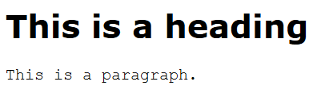

Text Size
The CSS font-size property defines the text size for an HTML element:
<h1 style="font-size:300%;">This is a heading</h1>
<p style="font-size:160%;">This is a paragraph.</p>
Op
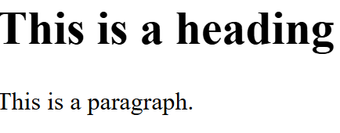

Text Alignment
The CSS text-align property defines the horizontal text alignment for an HTML element:
<h1 style="text-align:center;">Centered Heading</h1>
<p style="text-align:center;">Centered paragraph.</p>
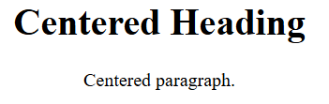
My code
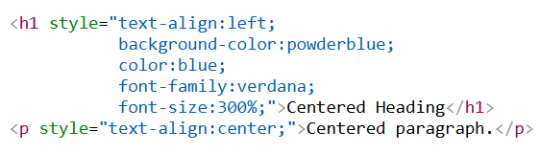
Op
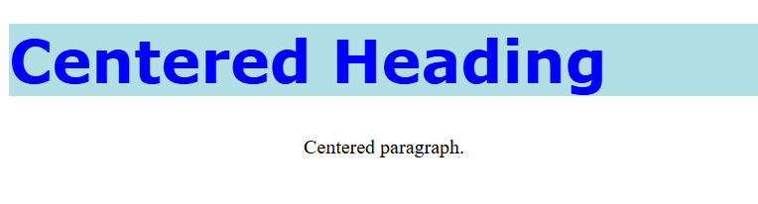

Border Color

You can set the color of borders:
<h1 style="border:2px solid Tomato;">Hello World</h1>
Op

Color Values
In HTML, colors can also be specified using RGB values, HEX values, HSL values, RGBA values, and HSLA values.
The following three <div> elements have their background color set with RGB, HEX, and HSL values:
rgb(255, 99, 71)
#ff6347
hsl(9, 100%, 64%)

<p>Same as color name "Tomato":</p>

<h1 style="background-color:rgb(255, 99, 71);">rgb(255, 99, 71)</h1>
<h1 style="background-color:#ff6347;">#ff6347</h1>
<h1 style="background-color:hsl(9, 100%, 64%);">hsl(9, 100%, 64%)</h1>

<p>Same as color name "Tomato", but 50% transparent:</p>
<h1 style="background-color:rgba(255, 99, 71, 0.5);">rgba(255, 99, 71, 0.5)</h1>
<h1 style="background-color:hsla(9, 100%, 64%, 0.5);">hsla(9, 100%, 64%, 0.5)</h1>

<p>In addition to the predefined color names, colors can be specified using RGB, HEX, HSL, or even transparent colors using RGBA or HSLA color values.</p>
Op
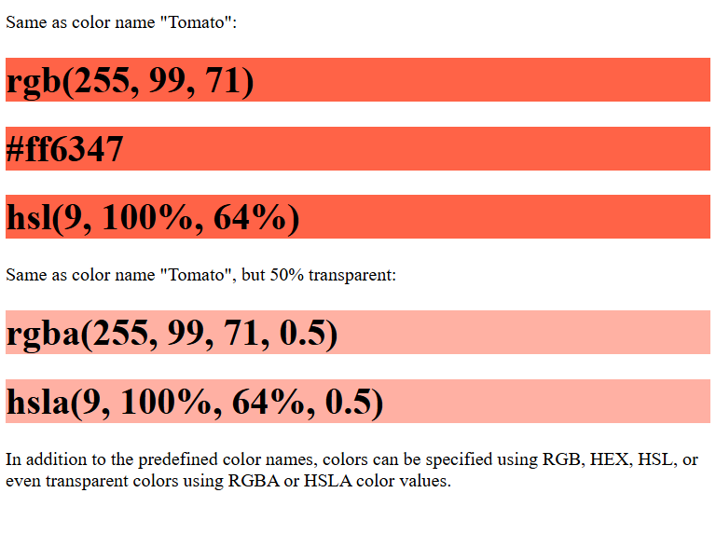

HTML Attributes
- All HTML elements can have attributes
- Attributes provide additional information about elements
- Attributes are always specified in the start tag
- Attributes usually come in name/value pairs like: name="value"

HTML Text Formatting
HTML contains several elements for defining text with a special meaning.
<p><b>This text is bold</b></p>
<p><i>This text is italic</i></p>
<p>This is<sub> subscript</sub> and <sup>superscript</sup></p>
Op
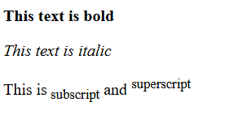

HTML Formatting Elements
Formatting elements were designed to display special types of text:
- <b> - Bold text
- <strong> - Important text
- <i> - Italic text
- <em> - Emphasized text
- <mark> - Marked text
- <small> - Smaller text
- <del> - Deleted text
- <ins> - Inserted text
- <sub> - Subscript text
- <sup> - Superscript text

HTML <b> and <strong> Elements
The HTML <b> element defines bold text, without any extra importance.
The HTML <strong> element defines text with strong importance. The content inside is typically displayed in bold.
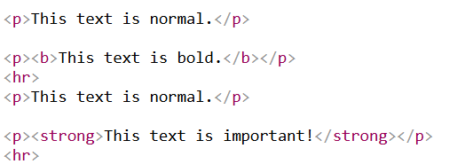
Op
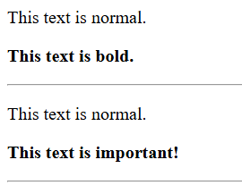

HTML <i> and <em> Elements
The HTML <i> element defines a part of text in an alternate voice or mood. The content inside is typically displayed in italic.
Tip: The <i> tag is often used to indicate a technical term, a phrase from another language, a thought, a ship name, etc.
The HTML <em> element defines emphasized text. The content inside is typically displayed in italic.
Tip: A screen reader will pronounce the words in <em> with an emphasis, using verbal stress.
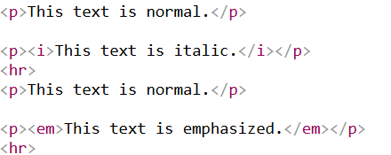
Op
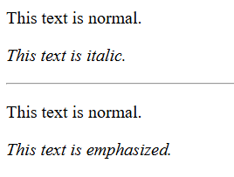

HTML <small> Element
The HTML <small> element defines smaller text:
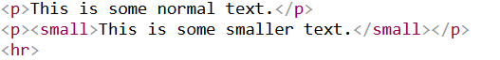
Op
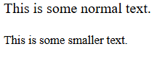

HTML <mark> Element
The HTML <mark> element defines text that should be marked or highlighted:
Op
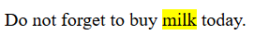

HTML <del> Element
The HTML <del> element defines text that has been deleted from a document. Browsers will usually strike a line through deleted text:
<p>My favorite color is <del>blue</del> red.</p>
Op
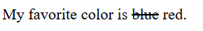

HTML <ins> Element
The HTML <ins> element defines a text that has been inserted into a document. Browsers will usually underline inserted text:
<p>My favorite color is <del>blue</del> <ins>red</ins>.</p>
Op

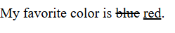

HTML <sub> Element
The HTML <sub> element defines subscript text. Subscript text appears half a character below the normal line, and is sometimes rendered in a smaller font. Subscript text can be used for chemical formulas, like H₂O:
<p>This is <sub>subscripted</sub> text.</p>
Op
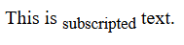

HTML <sup> Element
The HTML <sup> element defines superscript text. Superscript text appears half a character above the normal line, and is sometimes rendered in a smaller font. Superscript text can be used for footnotes, like WWW^{[1]}:
<p>This is <sup>superscripted</sup> text.</p>
Op
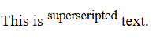

HTML <blockquote> for Quotations
The HTML <blockquote> element defines a section that is quoted from another source.
Browsers usually indent <blockquote> elements.
<p>Here is a quote from WWF's website:</p>
<blockquote cite="http://www.worldwildlife.org/who/index.html">
For 60 years, WWF has worked to help people and nature thrive. As the world's leading conservation organization, WWF works in nearly 100 countries. At every level, we collaborate with people around the world to develop and deliver innovative solutions that protect communities, wildlife, and the places in which they live.
</blockquote>
op
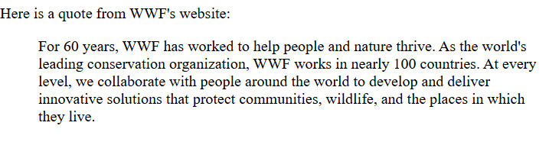

HTML <q> for Short Quotations
The HTML <q> tag defines a short quotation.
Browsers normally insert quotation marks around the quotation.
<p>WWF's goal is to: <q>Build a future where people live in harmony with nature.</q></p>
Op

HTML <abbr> for Abbreviations
The HTML <abbr> tag defines an abbreviation or an acronym, like "HTML", "CSS", "Mr.", "Dr.", "ASAP", "ATM".
Marking abbreviations can give useful information to browsers, translation systems and search-engines.
Tip: Use the global title attribute to show the description for the abbreviation/acronym when you mouse over the element.
<p>The <abbr title="World Health Organization">WHO</abbr> was founded in 1948.</p>
Op
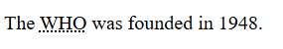
We use title, so when we place the cursor on WHO it displays as World Health Organization

HTML <address> for Contact Information
The HTML <address> tag defines the contact information for the author/owner of a document or an article.
The contact information can be an email address, URL, physical address, phone number, social media handle, etc.
The text in the <address> element usually renders in italic, and browsers will always add a line break before and after the <address> element.
<address>
Written by John Doe.<br>
Visit us at:<br>
Example.com<br>
Box 564, Disneyland<br>
USA
</address>
Op
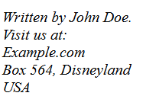

HTML <cite> for Work Title
The HTML <cite> tag defines the title of a creative work (e.g. a book, a poem, a song, a movie, a painting, a sculpture, etc.).
Note: A person's name is not the title of a work.
The text in the <cite> element usually renders in italic.
<p><cite>The Scream</cite> by Edvard Munch. Painted in 1893.</p>
Op
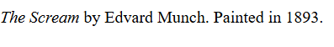

HTML <bdo> for Bi-Directional Override
BDO stands for Bi-Directional Override.
The HTML <bdo> tag is used to override the current text direction:
<bdo dir="rtl">This text will be written from right to left</bdo>
Op
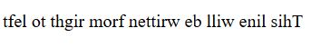

HTML Comments
HTML comments are not displayed in the browser, but they can help document your HTML source code.

HTML Comment Tag
<!-- Write your comments here -->
Notice that there is an exclamation point (!) in the start tag, but not in the end tag.
With comments you can place notifications and reminders in your HTML code:
Comments can be used to hide content.
This can be helpful if you hide content temporarily:
You can also hide more than one line. Everything between the <!-- and the --> will be hidden from the display.
Comments can be used to hide parts in the middle of the HTML code.

Example
Hide a part of a paragraph:
<p>This <!-- great text --> is a paragraph.</p>

HTML Styles - CSS
CSS stands for Cascading Style Sheets.
CSS saves a lot of work. It can control the layout of multiple web pages all at once.
It is used to format the layout of a webpage.
With CSS, you can control the color, font, the size of text, the spacing between elements, how elements are positioned and laid out, what background images or background colors are to be used, different displays for different devices and screen sizes, and much more!
Tip: The word cascading means that a style applied to a parent element will also apply to all children elements within the parent. So, if you set the color of the body text to "blue", all headings, paragraphs, and other text elements within the body will also get the same color (unless you specify something else)!
CSS can be added to HTML documents in 3 ways:
- Inline - by using the style attribute inside HTML elements
- Internal - by using a <style> element in the <head> section
- External - by using a <link> element to link to an external CSS file

Inline CSS
An inline CSS is used to apply a unique style to a single HTML element.
An inline CSS uses the style attribute of an HTML element.
<h1 style="color:blue;">A Blue Heading</h1>
Op
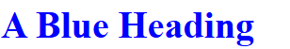

Internal CSS
An internal CSS is used to define a style for a single HTML page.
An internal CSS is defined in the <head> section of an HTML page, within a <style> element.
<!DOCTYPE html>
<html>
<head>
<style>
body {background-color: powderblue;}
h1 {color: blue;}
p {color: red;}
</style>
</head>
<body>
<h1>This is a heading</h1>
<p>This is a paragraph.</p>
</body>
</html>
op
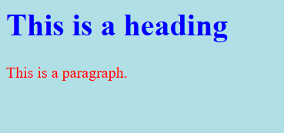

External CSS
An external style sheet is used to define the style for many HTML pages.
To use an external style sheet, add a link to it in the <head> section of each HTML page:
Tip: With an external style sheet, you can change the look of an entire web site, by changing one file!
<!DOCTYPE html>
<html>
<head>
<link rel="stylesheet" href="styles.css">
</head>
<body>
<h1>This is a heading</h1>
<p>This is a paragraph.</p>
</body>
</html>
The external style sheet can be written in any text editor. The file must not contain any HTML code, and must be saved with a .css extension.
Here is what the "styles.css" file looks like:
body { background-color: powderblue;}
h1 { color: blue;}
p { color: red;}
op
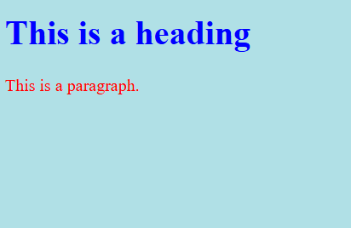

CSS Colors, Fonts and Sizes
Here, we will demonstrate some commonly used CSS properties. You will learn more about them later.
The CSS color property defines the text color to be used.
The CSS font-family property defines the font to be used.
The CSS font-size property defines the text size to be used.
<!DOCTYPE html>
<html>
<head>
<style>
h1 {
color: blue;
font-family: verdana;
font-size: 300%;
}
p {
color: red;
font-family: courier;
font-size: 160%;
}
</style>
</head>
<body>
<h1>This is a heading</h1>
<p>This is a paragraph.</p>
</body>
</html>

Op
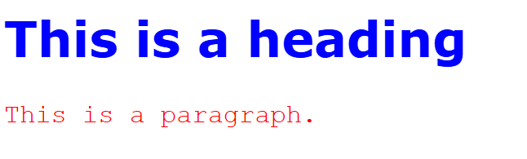

CSS Border
The CSS border property defines a border around an HTML element.
<!DOCTYPE html>
<html>
<head>
<style>
p {
border: 2px solid powderblue;
}
</style>
</head>
<body>

<h1>This is a heading</h1>

<p>This is a paragraph.</p>
<p>This is a paragraph.</p>
<p>This is a paragraph.</p>

</body>
</html>
Op
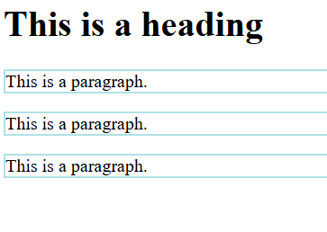

CSS Padding
The CSS padding property defines a padding (space) between the text and the border.
p {
border: 2px solid powderblue;
padding: 30px;
}
op
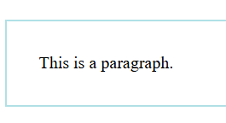

CSS Margin
The CSS margin property defines a margin (space) outside the border.
p {
border: 2px solid powderblue;
margin: 50px;
}
op
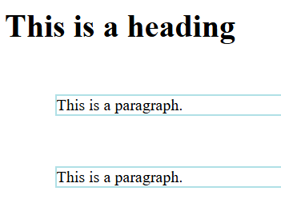

Link to External CSS
External style sheets can be referenced with a full URL or with a path relative to the current web page.
1.This example uses a full URL to link to a style sheet:
<link rel="stylesheet" href="https://www.w3schools.com/html/styles.css">

2.This example links to a style sheet located in the html folder on the current web site:
<link rel="stylesheet" href="/html/styles.css">
3.This example links to a style sheet located in the same folder as the current page:
<link rel="stylesheet" href="styles.css">

HTML File Paths

File Path Examples
Path | Description
<img src="picture.jpg"> | The "picture.jpg" file is located in the same  folder as the current page
<img src="images/picture.jpg"> | The "picture.jpg" file is located in the images folder  in the current folder
<img src="/images/picture.jpg"> | The "picture.jpg" file is located in the images  folder at the root of the current web
<img src="../picture.jpg"> | The "picture.jpg" file is located in the folder one  level up from the current folder

HTML File Paths
A file path describes the location of a file in a web site's folder structure.
File paths are used when linking to external files, like:
- Web pages
- Images
- Style sheets
- JavaScripts

Absolute File Paths
An absolute file path is the full URL to a file:
<img src="https://www.w3schools.com/images/picture.jpg" alt="Mountain">
Op
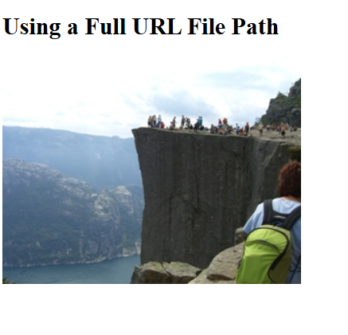

Relative File Paths
A relative file path points to a file relative to the current page.
In the following example, the file path points to a file in the images folder located at the root of the current website:

Example
<img src="/images/picture.jpg" alt="Mountain">
In the following example, the file path points to a file in the images folder located in the current folder:

Example
<img src="images/picture.jpg" alt="Mountain">
In the following example, the file path points to a file in the images folder located in the folder one level up from the current folder:

Example
<img src="../images/picture.jpg" alt="Mountain">

Best Practice
It is best practice to use relative file paths (if possible).
When using relative file paths, your web pages will not be bound to your current base URL. All links will work on your own computer (localhost) as well as on your current public domain and your future public domains.

